**JSON PARSER**

Team Members:

Guffrana Anjum

Alluri Praveenya

Andugula Anusha

**Project Description:**

The JSON Configuration Manager is a Python application designed to read, update, and validate configuration settings stored in a JSON file. This application aims to provide an intuitive interface for users to modify application settings while ensuring data integrity through validation checks. By leveraging JSON for configuration management, the application offers a lightweight, human-readable format for storing settings.

**Operations:**

* **Read the Configuration:** The script reads the JSON file into a Python dictionary.
* **Update Settings**: It prompts the user for new values and updates the configuration accordingly.
* **Validate Structure**: Before saving, it validates the updated configuration against a predefined schema to ensure all fields are correctly set.
* **Write Back**: If the configuration is valid, it writes the changes back to the JSON file.
* Run the Script python config_manager.py.

**Sample Input and Output:**

Input:

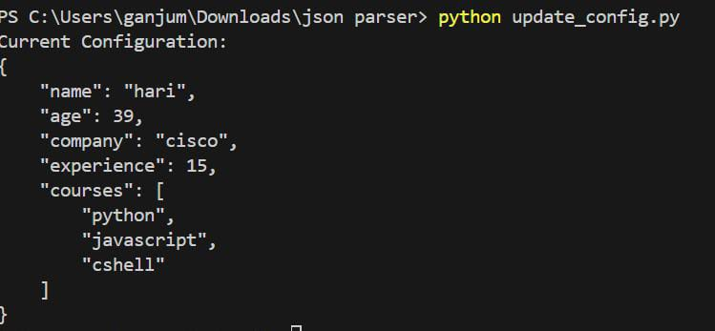

Output:

**Conclusion:**

The JSON Configuration Manager is a practical tool for managing application settings through a user-friendly interface. Its focus on validation and error handling makes it a reliable choice for developers and end-users alike, ensuring a seamless configuration experience. This project can be extended with additional features such as multi-file support, more complex settings, or a graphical user interface (GUI) for further enhancements.